Self-Alignment with Instruction Backtranslation
https://arxiv.org/pdf/2308.06259.pdf

Ideas
- Selfaugmentation: the base model is finetuned with (output, instruction) pairs from the seed examples as an instruction prediction model Myx, which is used to generate candidate instructions for outputs from the unlabelled data.
- Self-curation: starting from an intermediate instruction-following model M0 finetuned from seed examples only, it selects high-quality (instruction, output) pairs A (1) k from the candidates from the previous step, and uses them as finetuning data for the next intermediate model M1, which is in turn used to select training data for obtaining M2.
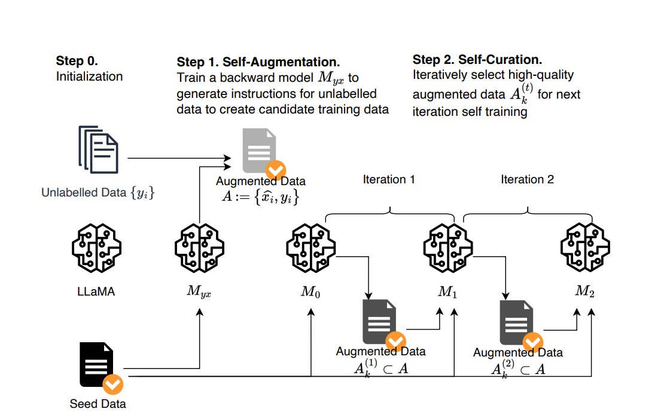

Steps

Initialization (seed data and unlabelled data)

Self-Augmentation (Myx := p(x|y))

Self-Curation (score augment data)
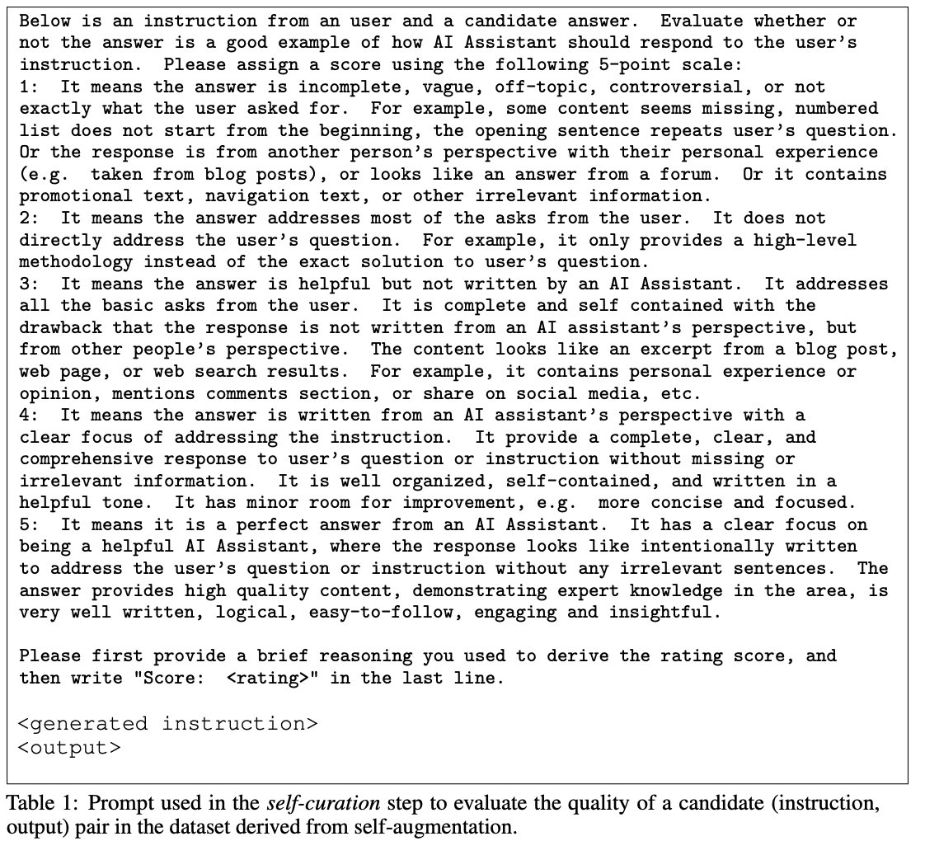

Dataset

Evaluation.
We evaluate on test prompts from several sources: Vicuna [Chiang et al., 2023] (80 prompts), Self-instruct [Zhang and Yang, 2023] (252 prompts), Open Assistant [Köpf et al., 2023] (188 prompts), Koala [Geng et al., 2023] (156 prompts), HH_RLHF [Bai et al., 2022a] (129 prompts), LIMA [Zhou et al., 2023] (300 prompts), crowdsourced from authors (64 prompts). In total there are 1130 unique prompts, providing a good coverage on a variety of task categories, e.g. writing, coding,

Seed and Augmentation Data Statistics
